Meine Postkarte

Replace this textbox with a picture or collage that you have choosen.

Here is a textbox to use for your postcard.
Replace this text with your typed postcard response. You need a MINIMUM of ten sentences describing your vacation. You will also need to have a salutation and closing.
On the other side of this card you also need to address your postcard to me!
Frau Kammanns Postkarte

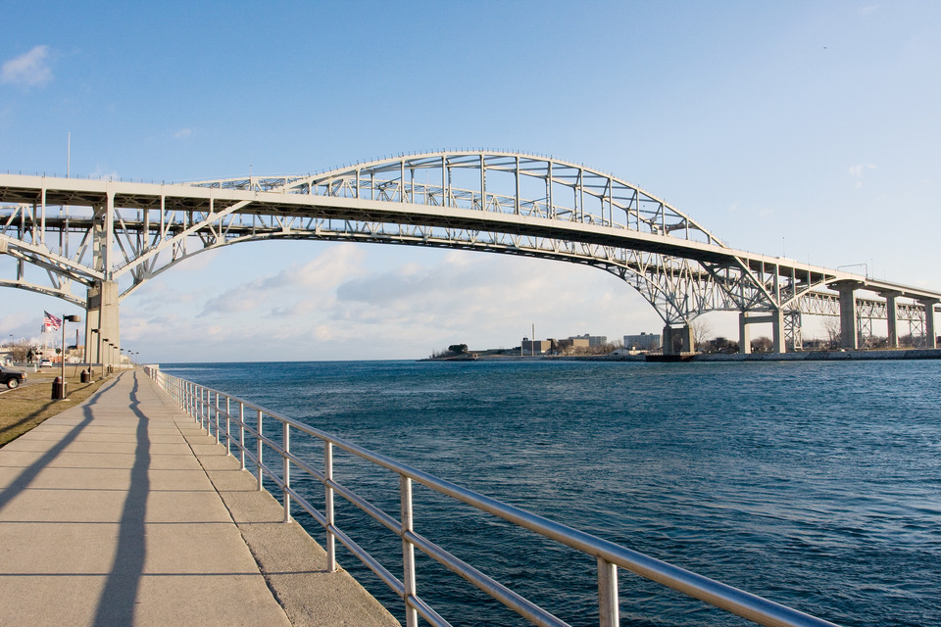

Deutsch III, Deutsch IV und Deutsch V/AP
Utica Schule, Zimmer 234
Utica, Michigan 48317
USA
Liebe Klasse!
Wie geht’s euch? Ich habe euch vermisst. Wie waren die Sommerferien? Was habt ihr gemacht? Gelesen? Gesehen? Habt ihr Deutsch gesprochen?
Ich habe nicht viel gemacht. Ich habe Port Huron besucht und dort die Segelboote geshen. Das war toll! Ich mag Segelboote gern. Ich habe dort auch eingekauft. Ich habe tolle Sandeln gekauft. Es gab auch einiges zu Hause, das wieder fertig gemacht brauchte. Das hat aber nicht viel Spass gemacht. Ich habe viele Bücher gelesen. Ich habe ein Paar DVDs gesehen. Ich sehe gern alte Filme. Ich habe im Garten gearbeitet. Leider sah der Garten nicht so schön aus. Er braucht mehr Hilfe. Ich habe auch meinen Neffen und meine Nichten gesehen. Nicht die ganz kleine aber ich werde sie zu Erntedankfest sehen. Ich habe auch Hausaufgaben gemacht und einiges Neues für euch. Hoffentlich gefällt es euch.
Was habt ihr dieses Jahr vor? Was erwartet euch?
Eure,
Frau

- Cicle all verbs-make a list
- Identify which tense
- What is the infinitive of the verb
- Identify adjective endings
- Identify nouns
- Identify gender of the nouns
- Identify case of nouns, explain why

